Chapter 5, Problem 62

Obtain the closed-loop voltage gain v_{o}/v_{i} of the circuit in Fig. 5.89.

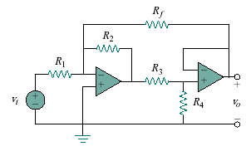
Figure 5.89
For Prob. 5.62.

